Image | 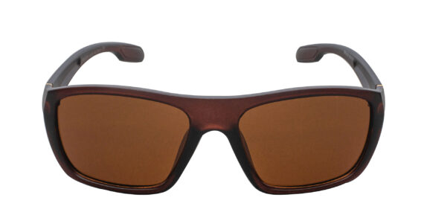
Brand | RAYBAN
Model Name | Felliz SFG
Price | RS 2000
PRODUCT DETAILS

